Retail & Membership Volunteers

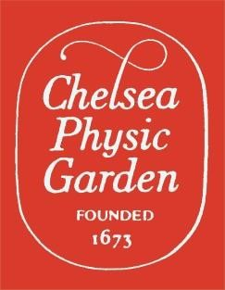
To help ensure every visitor to Chelsea Physic Garden has an excellent visitor experience we are recruiting a team of Retail & Membership Volunteers to help support our visitor-facing team.

As a Retail & Membership Volunteer you will be an advocate for CPG and help promote our work and values to our visitors, as well as answer questions about membership and serve a first point of contact for Friends of the Garden.

We have volunteers support every area of our charity. These vital contributions help us increase our impact year on year, and they provide individuals a chance to develop new skills, make friends and stay active.

Being a Retail & Membership Volunteers will involve:

- Working directly with our visitors and communicating with them about CPG and our membership programme alongside our retail offer.
- Processing sales, replenishing stock on the shop floor and preparing online sales for delivery.
- Helping complete stocktakes of retail inventory and other administrative tasks to support the team.
- Promoting the CPG membership offer and supporting membership transactions and conversions.
- Assist new and existing Friends with completing forms including updating contact details, purchasing gift memberships, upgrading memberships, requesting a replacement membership card and confirming Gift Aid eligibility.
- Assist with membership processes including preparing letter mailouts using Microsoft Word mail merge and stuffing/franking envelopes.
- Answering basic membership enquiries received via email and post.
- Contributing to our wider visitor experience outcomes to ensure every visitor leaves CPG with the curiosity sparked having had an excellent experience with us.

About You:

- You want to gain more experience working with visitors in an engaging way.
- You want to develop skills in customer service, visitor experience, delivering membership schemes, retail, teamwork, problem solving, and increased confidence.
- You want to meet people with similar values and contribute to a positive working environment.
- You want to support CPG’s charitable mission to help connect people with plants.

Commitment:

Options Available: As a six-day a week operation, CPG has plenty of opportunities to be involved. We would ask that you try to make a regular contribution of hours (e.g. three hours per week, 10:00am – 1pm on a Friday), we are happy to discuss commitment with you to suit your schedule.

 | Mon | Tue | Weds | Thurs | Fri | Sat | Sun
AM
PM

Volunteer Benefits:

By volunteering with CPG, you will receive the following benefits:
- Role specific training, alongside our core training programme.
- An annual Friends Membership to the Garden for you and a guest
- Travel expenses.
- An invitation to our annual Summer and Christmas Volunteers celebrations
- Updates on our organisational developments at Quarterly Meetings (made available with written updates for those who cannot attend in person)
Your contribution will make a difference.

