Horticultural Trainee
Job Application Pack

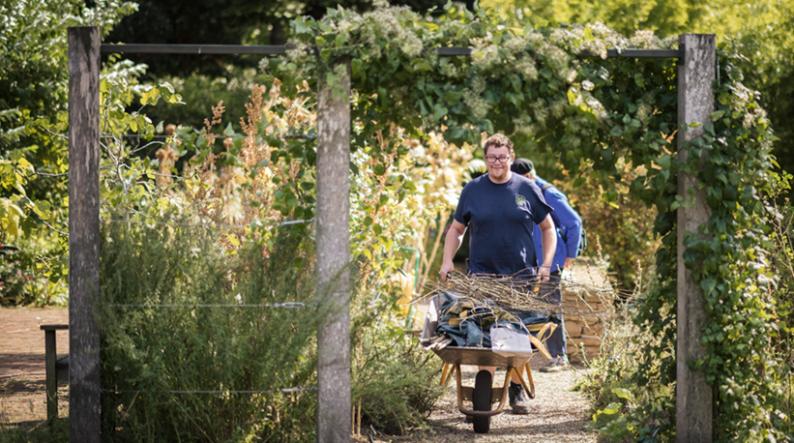
Image 1: A former CPG Trainee working at the Garden

Included in this pack:
- Job Description
- Equal Opportunities Monitoring Form
- Application Form
Help:
If you would like to know more about this position, or need support with your application please contact Allison Napier on jobs@chelseaphysicgarden.co.uk

This role is supported by the National Lottery Heritage Fund

Horticultural Trainee
Job Description

Job Title: Horticultural Trainee (Glasshouses)
Position: 2-year Fixed-Term Contract
Hours: Full time. Average 35 hours per week (working hours vary for summer and winter, details below) including weekend working as part of a rota.
Salary: £20,111per annum or London Living Wage, whichever is the higher
Holidays: 33 days per year including 8 Bank Holidays
Responsible to: Deputy Head of Plant Collections
Key Relationships: Gardener/Glasshouse Manager; Gardener/Records Manager; volunteers
Location: Based at Chelsea Physic Garden, Royal Hospital Road, London.
SW3 4HS.

About Chelsea Physic Garden
Chelsea Physic Garden is an independent charity set up in 1983 to promote and preserve the four-acre garden. The charity’s mission is to demonstrate the medicinal, economic, cultural and environmental importance of plants to the survival and wellbeing of people. Our small, dedicated team of staff are helped by knowledgeable and skilled volunteers.

There has been a garden on our site since 1673. The project to restore our Glasshouses is part of a larger project that will help us celebrate our 350 anniversary in 2023.

We take our responsibilities to the planet and to our Garden’s ecosystem seriously. The Garden is home to a wide variety of wildlife such as insects, birds and pondlife so it is important that we don’t use chemicals to control pests unless we have no other alternative. We recycle nearly all our garden waste and use the compost to improve the soil. We collect rainwater to water many of the plants in the glasshouses.

About the Role
This paid traineeship has been part-funded by the National Lottery Heritage Fund in conjunction with Chelsea Physic Garden’s Glasshouses Restoration Project. This is a very exciting time to join the Garden. The Horticultural Trainee (Glasshouses) will spend two years working alongside our team of experienced gardeners, volunteers and a wider team of experts.

During the two-year placement, the Trainee will be offered the time and support to study for the RHS Level 2 Certificate in the Principles of Horticulture (or similar). They will also be offered the opportunity to study for and take the PA1 and PA6a Safe Use of Pesticides qualification.

This role will give the Trainee the chance to gain practical horticultural experience both outdoors and inside the glasshouses while working in a small botanic garden with a rare plant collection. There will also be opportunities to work with our Learning Team who deliver workshops to a wide variety of people.

This trainee position is aimed at candidates with very little experience, and we encourage applications from people from all backgrounds, experiences, ages and communities. No previous experience as a gardener is needed. We will be holding an open day to allow anyone interested in this position to visit the Garden and ask the team any questions they may have. The date is Thursday 27 January.

The Trainee will report to the Deputy Head of Plant Collections and be supported by the Head of Plant Collections both of whom started in horticulture as trainees themselves.

KEY OBJECTIVES

The aim is for the Trainee to have the skills and experience to seek employment in this sector by the end of the two years. This will be achieved by the Trainee:

- being shown and given training in practical horticulture (gardening) particularly in the glasshouses.
- working in the glasshouses doing jobs that will include watering, feeding, growing new plants from seeds and cuttings, pruning, ventilation and pest control as well as helping with the restoration project.
- working in the garden outside doing jobs that will include border and path maintenance, pruning, mulching, compost turning, plant staking, turf care and machinery use.
- increasing their plant knowledge and identification skills by taking part in weekly plant identification sessions that are tailored to their stage of learning and development.
- writing a work diary to help combine their learning and practical experience.
- having dedicated time to complete an RHS level 2 qualification

At the end of the traineeship, the Trainee will have:
- gained a wide range of practical gardening skills and knowledge.
- experience of working in a team.
- an understanding of the importance of Health and Safety in the workplace and experience of working in a professional garden that complies with all relevant regulations.
- an understanding of the importance of COSHH (Control of Substances Hazardous to Health) to gain a pesticides qualification
- a record of working full-time and being able to take on responsibilities.
- an RHS Level 2 qualification

PERSON SPECIFICATION

Knowledge, Skills and Experience | Essential/ Desirable
An interest in plants. | E
An enthusiastic person who is really interested in a career in horticulture and is willing to get involved in all aspects of gardening. | E
Willing to work towards a recognised Level 2 horticultural qualification by attending college on a day release basis. | E
No previous horticultural skills are needed but must be happy to do any formal training that is needed. For example, the qualification to spray pesticides. | E
Some experience of working or volunteering outside in all weathers. | D
Ability to work well as part of a small team. | E

Additional Information:

Working Hours:

The gardeners work 35 hours per week on average, but the working pattern is different for summer and winter months.

1 March to 31 August: Monday to Thursday - 8am to 5pm
Friday – 8am to 4pm
1 September to 28 February Monday to Thursday – 8am to 3.30pm
Friday – 8am to 1pm

There is a one-hour unpaid lunch break.

Chelsea Physic Garden is committed to being an equal opportunities employer.

Our organisational values are:
- Inclusion
- Sustainability
- Openness & Transparency
- Respect & Care
- Discovery & Enrichment
This role has been made possible by the support of the National Lottery Heritage Fund and other charitable trusts and funders.

The Garden operates a salary exchange pension scheme with Royal London. The equivalent contribution rates are 5% employer and 3% employee at the end of the probationary period.

Returning your application:
Please complete the job application form and equal opportunities form and email them to jobs@chelseaphysicgarden.co.uk

Dates:
Thursday 27 January 2022 10am to 2pm
Open Day: a chance for you to visit the garden, meet the garden team and ask any questions before applying for the position.

Friday 18 February
Closing date for applications

Thursday 3 March
First interview via Zoom (or at the Garden if necessary)

Wednesday 9 March
Second interview at the Garden

